**OBONG UNIVERSITY**

**OBONG NTAK, ETIM EKPO LGA, AKWA IBOM STATE**

**DEPARTMENT OF COMPUTER SCIENCE**

**SIX MONTHS REPORT ON STUDENTS INDUSTRIAL WORK EXPERIENCE SCHEME (SIWES)**

**AT**

**START INNOVATION HUB**

**GROUND FLOOR, ROOM 11, IBOM E-LIBRARY, UYO, AKWA IBOM STATE.**

**ADRIAN ROCA MOCHE**

**U1CS1702DE**

**SIWES SUPERVISOR:**

**OCTOBER, 2019.**

**OBONG UNIVERSITY**

**OBONG NTAK, ETIM EKPO LGA, AKWA IBOM STATE**

**DEPARTMENT OF COMPUTER SCIENCE**

**SIX MONTHS REPORT ON STUDENTS INDUSTRIAL WORK EXPERIENCE SCHEME (SIWES)**

**AT**

**START INNOVATION HUB**

**GROUND FLOOR, ROOM 11, IBOM E-LIBRARY, UYO, AKWA IBOM STATE.**

**ADRIAN ROCA MOCHE**

**U1CS1702DE**

**HEAD OF DEPARTMENT:**

**MR KUFRE UKPE**

**SUBMITTED IN PARTIAL FULFILLMENT OF THE REQUIREMENTS FOR THE AWARD OF BACHELOR OF SCIENCE (B.Sc) DEGREE, IN THE FACULTY OF SCIENCE, OF OBONG UNIVERSITY, OBONG NTAK, ETIM EKPO LGA, AKWA IBOM STATE**

**DEDICATION**

This report is dedicated foremost to God almighty for his favour, mercy and grace upon my life especially during my six (6) months SIWES programme at Start Innovation Hub.

I would also like to dedicate it to my parents and siblings for their love and support and everyone else that contribute towards making my SIWES training a fun and successful one.

**AKNOWLEDGEMENT**

My appreciation goes to the Industrial Training Fund for their foresight in putting this program in place.

I am grateful to Start Innovation Hub for providing me with the necessary skills to be exposed in my field. I also want to say a big thank you to my industry based supervisor Mr. Patrick Inyangetoh and my able colleague for making my stay at Start Innovation Hub an exciting and blissful one. To my parents and siblings thank you all for your moral and financial support. I cannot wish for a better family. I am deeply indebted to God almighty, the giver of all wisdom, knowledge and understanding, without whom I would have achieved nothing at all. Finally to my Institution based supervisor for his support and to my other friends and colleagues. Thank you all, I am highly grateful.

**ABSTRACT**

This industrial report presents the experience gained during my six (6) months of industrial training undertaken at Start Innovation Hub, Ground floor, room 11, Ibom E-Library, Uyo, Akwa Ibom State.

My training was on Web Development and Advanced Web Design.

I acquired practical knowledge on how to design a web site as a good front-end web developer.

This report discusses the technical skills gained during the training period and justifying the relevance of the scheme in equipping students with needed technical competence to thrive in the real world.

**TABLE OF CONTENT**

**Cover Page**

**Title Page**

Dedication……………………………………………………………………...1

Acknowledgement……………………………………………………………..2

Abstract…………………………………………………………………….......3

Table of Content……….……………………………..………………….…….4

**Chapter 1**

**Introduction………………………………....………………………….…..….1**

Purpose of training...……………………….………....…….………….…….....6

Brief story of SIWES………...…….……….……………….………….….......6

Bodies involved in SIWES....………….………..…………….….……….…....7

Aims and objectives of SIWES………….….…….…………………………….7

Benefits of Industrial Training…………….…….…………………….….….....8

Description of the establishment of the attachment…………….....…………..8

Objectives and vision of Start Innovation Hub......…………………….….......8

Company’s area of specialization……….………………………………….….9

Departments in the company……….……………………………………….....9

**Chapter 2**

**Industrial Experience………………………………...……….……………………………2**

Web development department…………...……...……………………….........10

Definition of terms…………………………………….…………………….....10

HTML and its properties………………………………………………….…....10

CSS and its properties……...…………………………………………….….....13

Website design using HTML and CSS……………………………….….......14

JavaScript and its properties……………...………………………………........17

**Chapter 3**

**Skills acquired and challenges encountered………………………………....3**

Technical skills acquired……………….……………………………………....25

Social and functional skills acquired..................................................................25

Personal input to the company (Start Innovation Hub)………………...….....25

Challenges encountered…………….…………………………………….…....26

**Chapter 4**

**Conclusion and Recommendations………………………….………………4**

Conclusion………………………………………………………………….......27

Recommendations……………….……………………………………..............27

**Reference………….…………………………………………………………..28**

**CHAPTER 1**

**INTRODUCTION**

1. **PURPOSE OF TRAINING:**

The student industrial work experience scheme (SIWES) popularly called Industrial Training (IT) by Nigerian students is a yearly program design by the institution in collaboration with the industries to give students the opportunity to gain practical working experience in their various field of study or area of specialization. It is an effort to bridge the existing gap between classroom theories and practical’s in engineering, management and other professional programs in the Nigerian tertiary institutions.

Training is a key factor in changing expertise of a workforce. The world is passing through one of the worst economic crisis in recent time. Both the developed and developing economics are experiencing serious economic downturns.

Globalization has turned the world into one big village and whatever happens in one economy will have effects in other economics, and the growing concern among our industrialist is that graduates of our institutions of higher learning, lack adequate practical background studies, so as to help in the industries led to the formation of Student Industrial Work Experience Scheme (SIWES) by ITF 1993/1994.

It is through this Industrial Training that the educational systems aims at helping students acquire appropriate skills, abilities and competencies, both mental and physical, as well as equip the individuals to live in society. The focus of the Industrial Training Fund (ITF) is for the industries of our countries to succeed in the face of the current economic meltdown.

No society can achieve meaningful progress without encouraging its youth to acquire necessary practical skills. Such skills enable them to harness available resources to meet the needs of the society. It was against this background that SIWES, otherwise referred to as industrial Training (IT), was introduced in Nigerian tertiary institution.

* 1. **SIWES: (Student Industrial Work Experience Scheme)**

Since the aim of our national policy in education is to build a strong and self- reliant nation, from the government’s decree No.47 of 8th October, 1971 as amended in1990, which led to the establishment of Industrial Training Fund (ITF) in 1973/1974 and through the formation of this body (ITF), in the year 1993/1994 and through the formation of this body (ITF), in the year 1993/1974 SIWES was formed. In Nigeria, the current form of Cooperative Education is known as the Students Industrial Work Experience Scheme (SIWES).

The Students Industrial Work Experience Scheme (SIWES) is a planned and supervised training intervention based on stated and specific learning and career objectives and geared towards developing the occupational competencies of the participants. The aim is make education more relevance and also to bridge the science-related disciplines in tertiary institutions in Nigeria.

SIWES forms part of the approved minimum academic standards in the institutions, and is a core academic requirement carrying fifteen (15) credit units. This requirement must be met by all students in various disciplines before graduation.

* 1. **BODIES INVOLVED IN SIWES:**

The main bodies involved in Student Industrial Work Experience Scheme are;

The tertiary institutions and the Federal Government through the Industrial Training Fund (ITF).

Other supervising agencies include:

1. National University Commission (NUC)
2. National Board for Technical Education (NBTE)
3. National Council for colleges for Education (NCCE)
4. Industry/Employers (NECA, NACCIMA, MAN, Government Establishments)
5. Tertiary Institutions (Universities, Polytechnics, Colleges of Education)
6. Student Trainees (Engineering, Science, Technology, NCE Technical).

The functions of these agencies above are to:

1. Ensure adequate funding of the scheme
2. Establish SIWES and accredit SIWES unit in the approved institutions
3. Formulate policies and guideline for participating bodies and institutions as well as appointing SIWES coordinators and supporting staff
4. Supervise students at their places of attachment and sign their log book and ITF forms.
5. Vet and process students Log books and forward same to ITF area office
6. Ensure payment of all allowances for the students and supervisors.
   1. **NATURE AND SCOPE OF SIWES:**

This is based on the number of weeks or months that student is expected to stay for its attachment. The minimum duration for SIWES should normally be six months, twenty-four weeks (24) weeks for University Engineers and Technologist. The cumulative total duration of attachment over the entire period of the course should preferably be not shorter than 240hrs full time which will take place during term-time or long vocation.

Induction sessions which is conducted by teaching departments to install the concepts of key skills (skills for learning, employment and life), work place safety and professional expectations, legalities and ethics.

* 1. **AIMS AND OBJECTIVES OF SIWES:**

The specific objectives of SIWES were summarized by the federal government as follows:

1. To provide students with an opportunity to apply their knowledge in real work and actual practice.
2. To make the transition from school to the world of work easier and to enhance students contacts for later job placement.
3. Advanced countries, with over 100 years of sustained industrial development and requisite technical and human infrastructure, have been able to adequately implement industrial training for their students.
4. They also include providing a structural attachment program with emphasis applications, management and hands-on experience for students to apply knowledge acquired.
5. It also aids students to acquire practical skill in other to strengthen their work value.
6. Moreover it helps them to gain interpersonal and entrepreneurial skills and also instil in them the right kind of work attitudes and professionalism through interactions with peoples in the organizations and observations of their future role in the tertiary.
   1. **BENEFITS OF INDUSTRIAL TRAINING:**

Experts identified industrial experience as necessity for proper job preparation. This is because productivity is enhanced by experience graduate or new entrance into the world of work really needs and early exposure to the value and skills of the industry. Therefore, without appropriate skills and experiences young graduates are not properly trained on work, norms and role behaviour among others, these components will ensure success at the job place.

Today Information and Communication Technology (ICT) is changing the way many jobs are performed, thus altering the knowledge and skills required of workers. Consequently, a new level of competency is required of our students. This cannot be sufficiently met by training facilities in our education institutions hence, the need for collaborative effort between institutions and industrial sector.

The major benefits accruing to students who participate conscientiously in industrial training are the skills and competencies they acquire. These relevant production skills (RPSs) remain a part of the recipients of industrial training as lifelong assets which cannot be taken away from them. This is because the knowledge and skills acquired through training are internalized and become relevant when required to perform jobs or functions. Several other benefits can accrue to students who participate in industrial training.

Provision of an enabling environment where students can develop and enhance personal attributes such as critical thinking, creativity, initiative, resourcefulness, leadership, time management, presentation skills and interpersonal skills, amongst others.

**1.6** **DESCRIPTION OF THE ESTABLISHMENT OF THE ATTACHMENT**

The establishment is called Start Innovation Hub; it is an information and communication technology company with broad expertise in ICT consultancy. Start Innovation Hub is a Nigerian based telecommunications and technology conglomerate in co-operated in ----- and offering a wide range of automated and integrated solution in broad spectrum of information and communication technology. This large corporation is on record to be the cheapest source for high quality goods and services and has a high reputation for performance in the distribution software development, web development, graphics design training, android development etc.

**1.7** **OBJECTIVES AND VISION OF START INNOVATION HUB**

1. To serve as a catalyst for both individual and collective development through the provision of cutting edge technological server’s solution, resources and guidance.
2. To produce professionals in this era of global technologies.
3. To offer a wide range of automated and integrated solution in broad spectrum of computer and telecommunication.
4. To build bridges between need and the solution.
5. Start Innovation Hub is position to offer unique and innovative solution to client in terms of technologies.
6. Our vision is to become the leading full-service information and communication technology.

**1.8 COMPANY’S AREA OF SPECIALIZATION**

With a team of seasoned computer Engineers and Programmers with proven track records in computer and communication business, the company offers the following wide areas of specialization

1. Repairs, Assembling and Maintenance of computers
2. Software Development and Maintenance
3. Computer Networking and Maintenance
4. Web and Android Development
5. Internet and E-mail Services
6. Training Services
7. Graphics Designing/ UI/UX and Digital Marketing

**1.9 DEPARTMENTS IN THE COMPANY**

1. Computer repair and maintenances department/ IOT
2. Software development department
3. Digital Marketing Department
4. Web and Android Development department
5. Graphics Design department

**CHAPTER 2**

**INDUSTRIAL EXPERIENCE**

**2.0 WEB DESIGN DEPARTMENT**

This department was where my Industrial Training took place where i was grounded and expose to the website world especially the creation of websites taking me step by step with practical all through the process.

**2.1 DEFINITION OF TERMS**

The following are terms that were made use of, in this department

**WEBSITE:**

A website is a set of related WebPages containing content such as texts, images, videos, audios, etc. A website is hosted on at least one web server, accessible via a network such as the internet or a private LAN through an internet address known as a URL (Universal Resource Locator). A publicly accessible websites collectively constitutes the World Wide Web (WWW).

**WEBPAGE:**

A webpage is a document, typically written in plain text interspersed with formatting instructions of hypertext nark up language (HTML, XHTML). A webpage may incorporate elements from other websites with suitable anchors. WebPages are accessed and transported with the hypertext transfer protocol (HTTP), which may occasionally employ encryption (HTTP secure, HTTPS) to provide security and privacy for the use of the webpage content. The user’s application often a web browser renders the page content according to its HTML mark-up instructions into a display terminal.

**HTTP:**

This stands for Hyper Text Transfer Protocol which is the set of rules for transferring files (text, graphic, images, sound, video, and other multimedia files) on the World Wide Web.

**URL:**

This stands for Uniform Resource Locator and as the name suggests, it provides a way to locate a resource on the web, the hypertext system that operates over the internet.

**2.2 HTML AND ITS PROPERTIES**

HTML stands for **H**yper**t**ext **M**ark-up **L**anguage, and it is the most widely used language to write Web Pages.

* **Hypertext** refers to the way in which Web pages (HTML documents) are linked together. Thus, the link available on a webpage is called Hypertext.
* As its name suggests, HTML is a **Markup Language** which means you use HTML to simply "mark-up" a text document with tags that tell a Web browser how to structure it to display.

Originally, HTML was developed with the intent of defining the structure of documents like headings, paragraphs, lists, and so forth to facilitate the sharing of scientific information between researchers.

Now, HTML is being widely used to format web pages with the help of different tags available in HTML language.

**2.2.1 HTML TAGS:**

As told earlier, HTML is a markup language and makes use of various tags to format the content. These tags are enclosed within angle braces **<Tag Name>**. Except few tags, most of the tags have their corresponding closing tags. For example, **<html>**has its closing tag**</html>**and **<body>**tag has its closing tag **</body>**tag etc.

The following are the names of tags and their description.

|  |  |
| --- | --- |
| **Tag** | **Description** |
| <html> | This tag encloses the complete HTML document and mainly comprises of document header which is represented by <head>...</head> and document body which is represented by <body>...</body> tags. |
| <head> | This tag represents the document's header which can keep other HTML tags like <title>, <link>, <script language =”javascript”> etc. |
| <title> | The <title> tag is used inside the <head> tag to mention the document title. |
| <body> | This tag represents the document's body which keeps other HTML tags like <h1>, <div>, <p>, <table> etc. |
| <h1> | This tag represents a heading |
| <p> | This tag represents a paragraph. |
| <b>, <i>, <li>, <ul> | Bold, italic, list, unordered list |

**2.2.2 HTML TABLE:**

The HTML table model allows web designers to arrange data –text, preformatted text, images, links, forms, form fields, other tables, etc. into rows and columns of cells. It is defined with the <table> tag.

Table are divided into table rows with the <tr> tag. Table rows are divided into table data with the <td> tag. A table row can also be divided into table headings with the <th> tag.

Table data <td> are the data containers of the table. They can contain all sorts of HTML elements like text, images, lists, other tables.

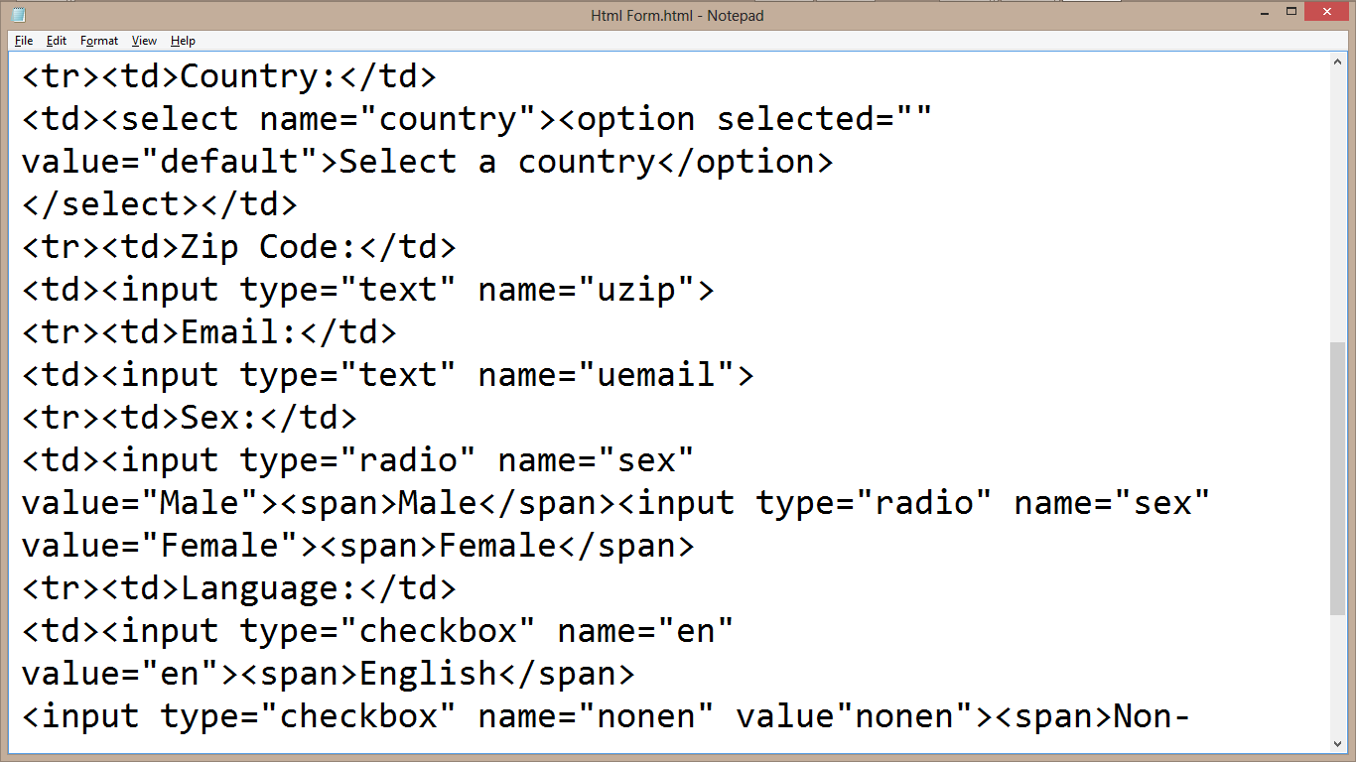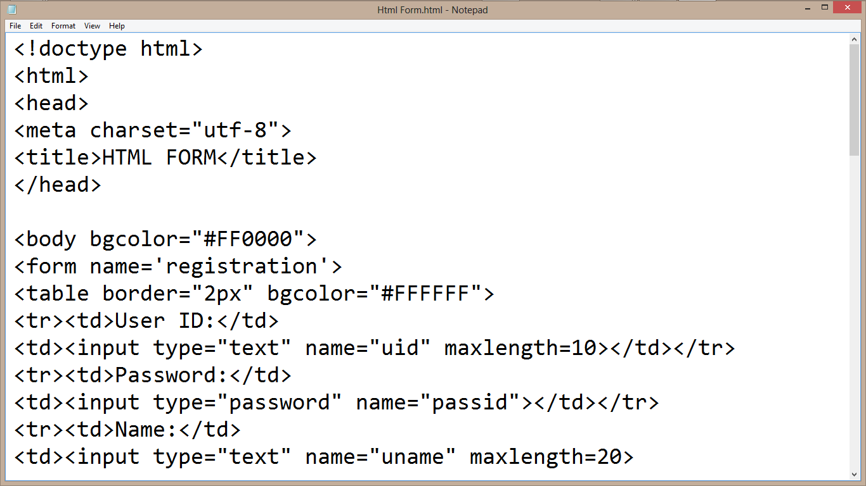**CODE VIEW**

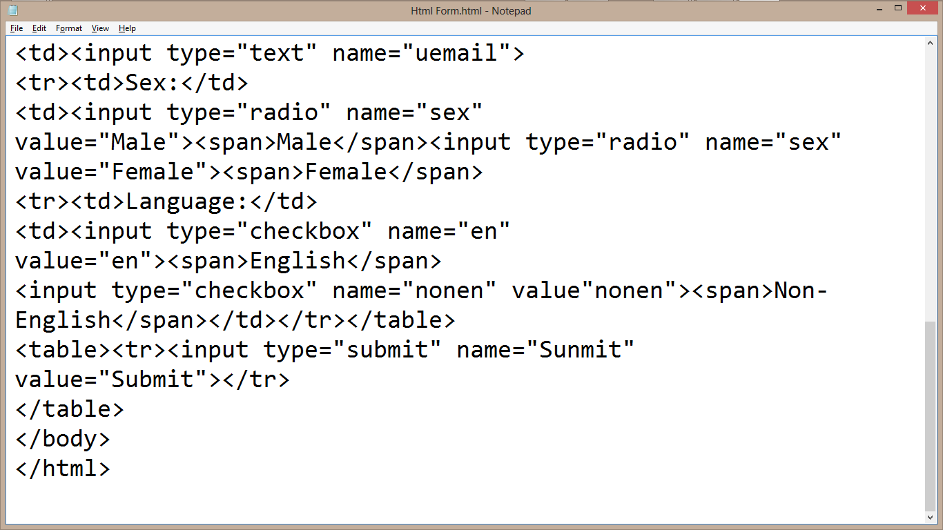

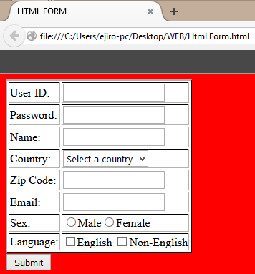 **DESIGN VIEW**

**2.3 CSS AND ITS PROPERTIES**

CSS stands for **C**ascading Style Sheet used for formatting html document. It is a style sheet language used for describing the presentation of a document written in a mark-up language.

**Note:** CSS code is not written the same way as HTML code is. This makes sense because css is not HTML, but rather a way of manipulating existing HTML.

**2.3.1 REASONS FOR CSS**

The following are reasons why CSS is better

1. It saves time
2. It eradicate the idea of using repeating codes
3. It provides efficiency in design and updates: with css, we are able to create rules, and apply those rules to many elements within the website.
4. It can lead to faster page downloads: since rules are only downloaded once by the browser, then are the cached and used for each page load, the use of css can lead to lighter page loads, and improved performance. This contributes to lighter server loads and lower requirements, which overall saves money for our clients.

It creates external file (server side) for managing html content.

**2.3.2 METHOD USED BY CSS IN FORMATTING HTML DOCUMENT**

1. **Inline Style:** It is used to apply a unique style to a single HTML element. An inline CSS uses the style attribute of an HTML element.
2. **Embedded / Internal Style:** It is used if one single page has a unique style. Internal styles are defined within the <style> element, inside the <head> section of an HTML page.
3. **External Style:** With an external style sheet, you can change the look of an entire website by changing just one file. Each page must include a reference to the external style sheet file inside the <link> element. The <link> element goes inside the <head> section. Also when using external css it is preferable to keep the css separate from your HTML. Placing CSS in a separate file allows the web designer to completely differentiate between content (HTML) and design (CSS). External CSS is a file that contains only CSS code and is saved with a “.css” file extension. This CSS is then referenced in your HTML using the <link> instead of <style> as earlier stated.

**2.3.3 CSS SELECTORS AND HOW THEY CAN BE USED**

CSS selectors are used to find or select HTML elements based on their element name, id or class

1. **Element Selector:** The element selector selects elements based on the element name.
2. **Id Selector:** The id selector uses the id attribute of an HTML element to select a specific element. The id of an element should be unique within a page, so the id selector is used to select one unique element. e.g. id=”hello” css #hello { color : red;}
3. **Class Selector:** The class selector selects elements with specific class attribute. To select elements with a specific class, write a period (.) character followed by the name of the class. e.g. .center {text-align: center;}

**2.3.4 CSS RULES OVERRIDING**

1. Any inline style sheet takes the highest priority, so it will override any rule defined in <style>……</style> tags.
2. Any rule defined in <style>………</style> tags will override the rules defined in any external style sheet file.

**2.3.5 CSS COMMENTS**

To simply put comment inside a style sheet you use /*………..*/, you can use it to comment multi-line blocks in similar way as you do in c and c++ programming language.

**2.3.6 BACKGROUND AND FONT OF VARIOUS HTML ELEMENTS**

You can set the following background properties of an element.

1. **The background-color:** Is a property used to set the color background of an element.
2. **The background-image property:** is used to set the background image of an element.
3. **The background repeat:** Is used to control the repetition of an image in the background.
4. **The background position:** Is used to control the position of an image in the background.
5. **The background attachment:** Is used to control the scrolling of an image in the background.
6. **The background property:** Is used as a short hand to specify a number of other background properties.

**FONT WHICH ARE;**

1. **The Font-family property:** This is used to change the face of a font
2. **The Font-style property:** This is used to make a font italic or oblique.
3. **The Font-weight property:** This is used to increase or decrease how bold or light a font appears.
4. **The Font-size property:** This is used to increase or decrease the size of a font.

**2.3.7 TEXT DECORATION:**

This demonstrate how to decorate a text in css, the values are none, underline, over line, line through and blink.

**2.3.8 PROPERTIES OF HYPERLINK USING CSS**

1. The link signifies unvisited hyperlinks
2. The link visited signifies visited hyperlinks
3. The link hovered signifies an element that currently has the user’s mouse pointer hovering over it.

The link active signifies an element on which the user is currently clicking.

**2.3.9 USING CSS FRAMEWORKS**

1. The use of bootstrap
2. Bulma also can used while creating a well responsive website.

**2.4 WEBSITE DESIGN USING HTML AND CSS**

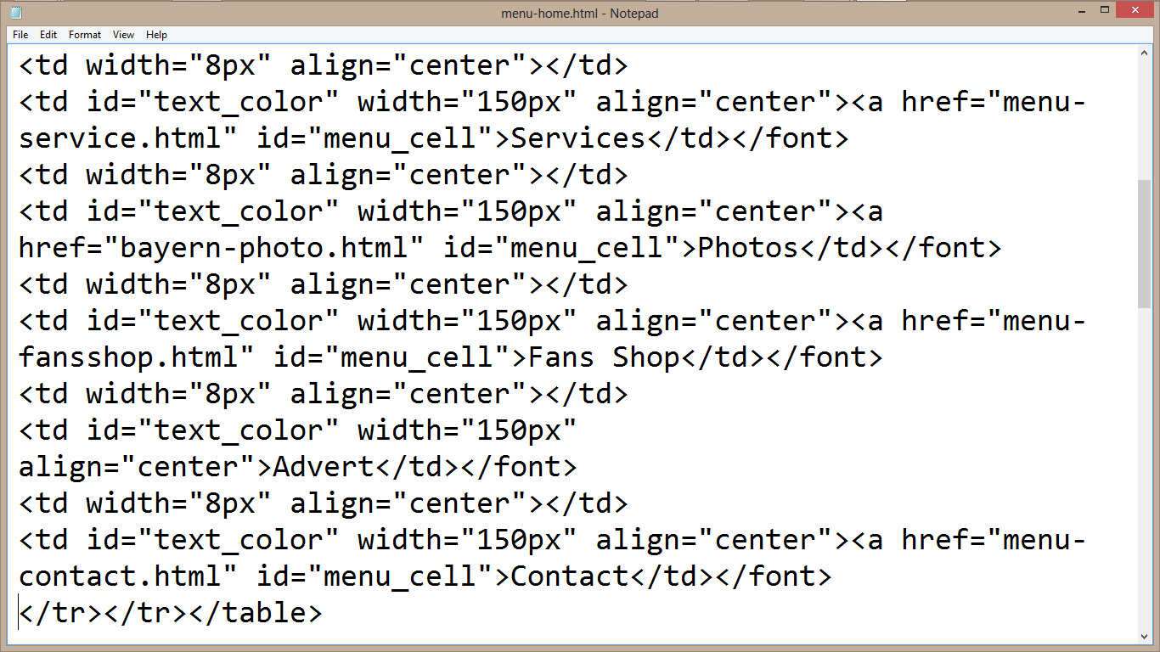**HTML CODING VIEW**

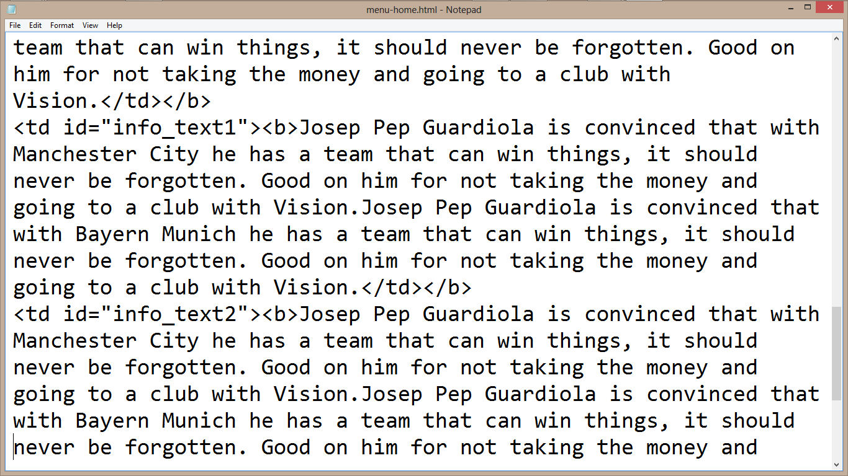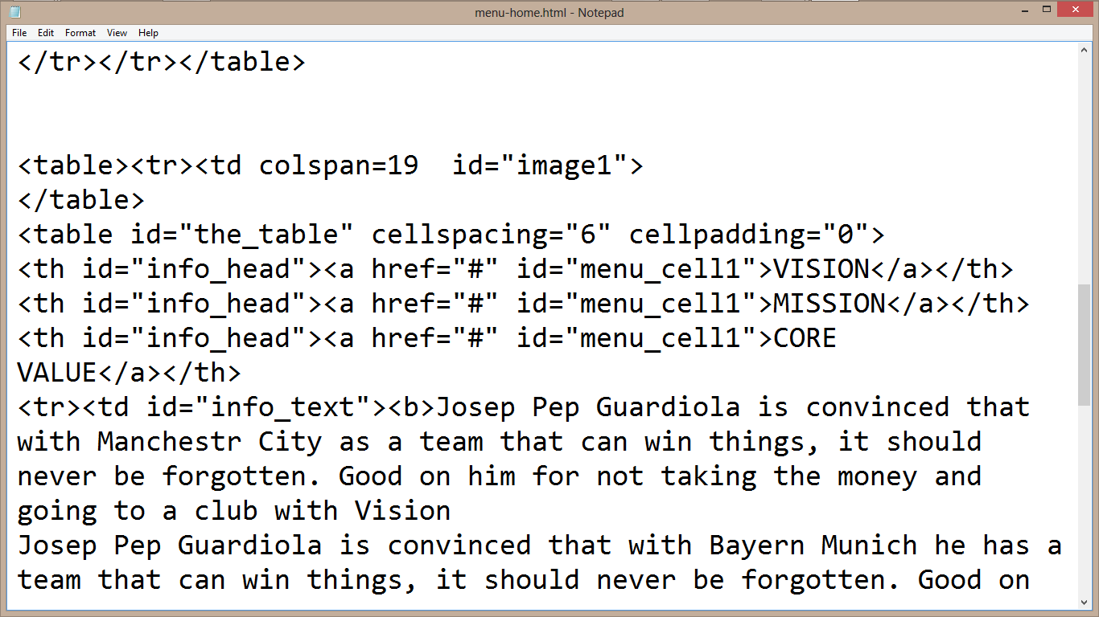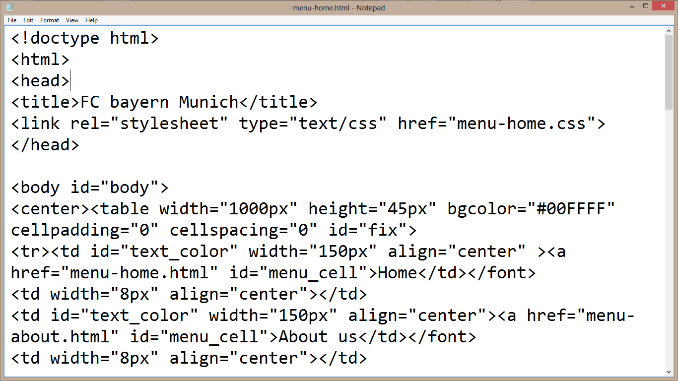

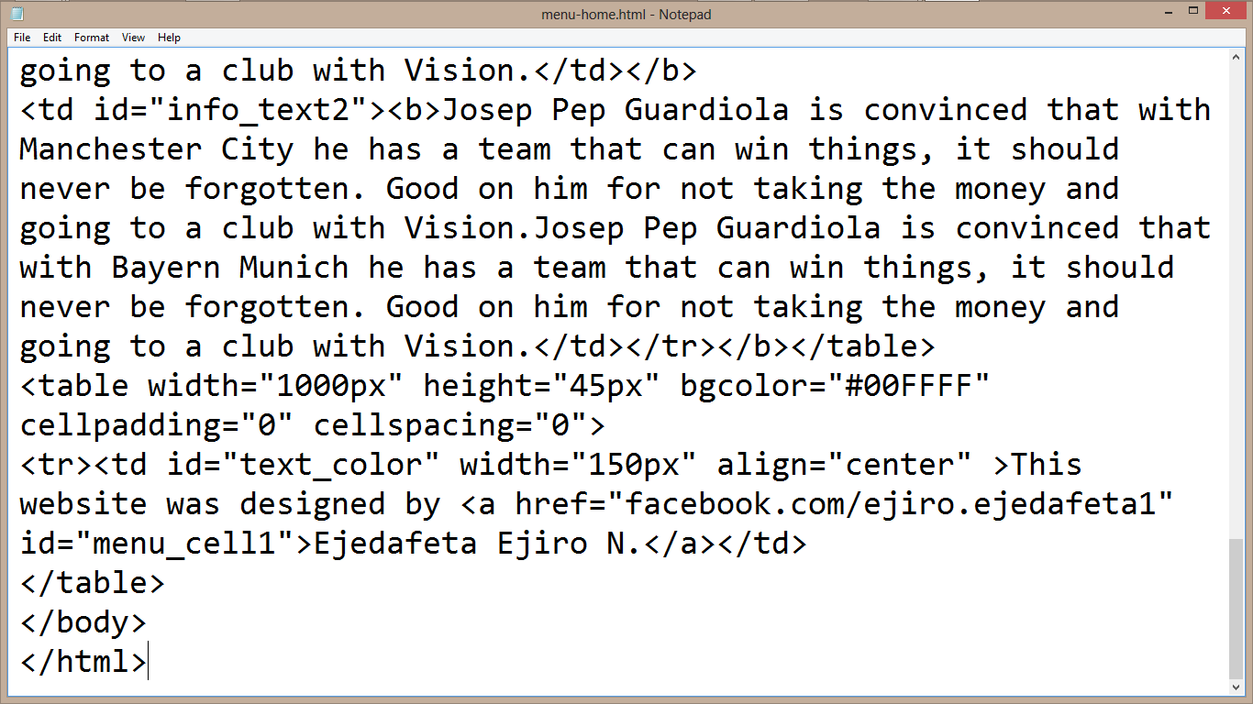

**CSS CODING VIEW**

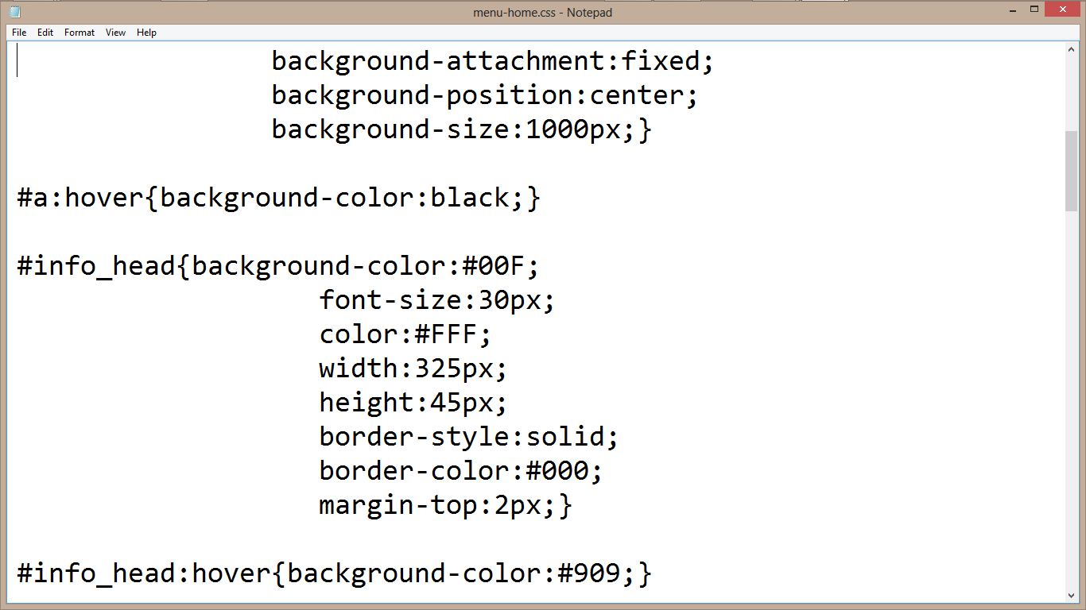

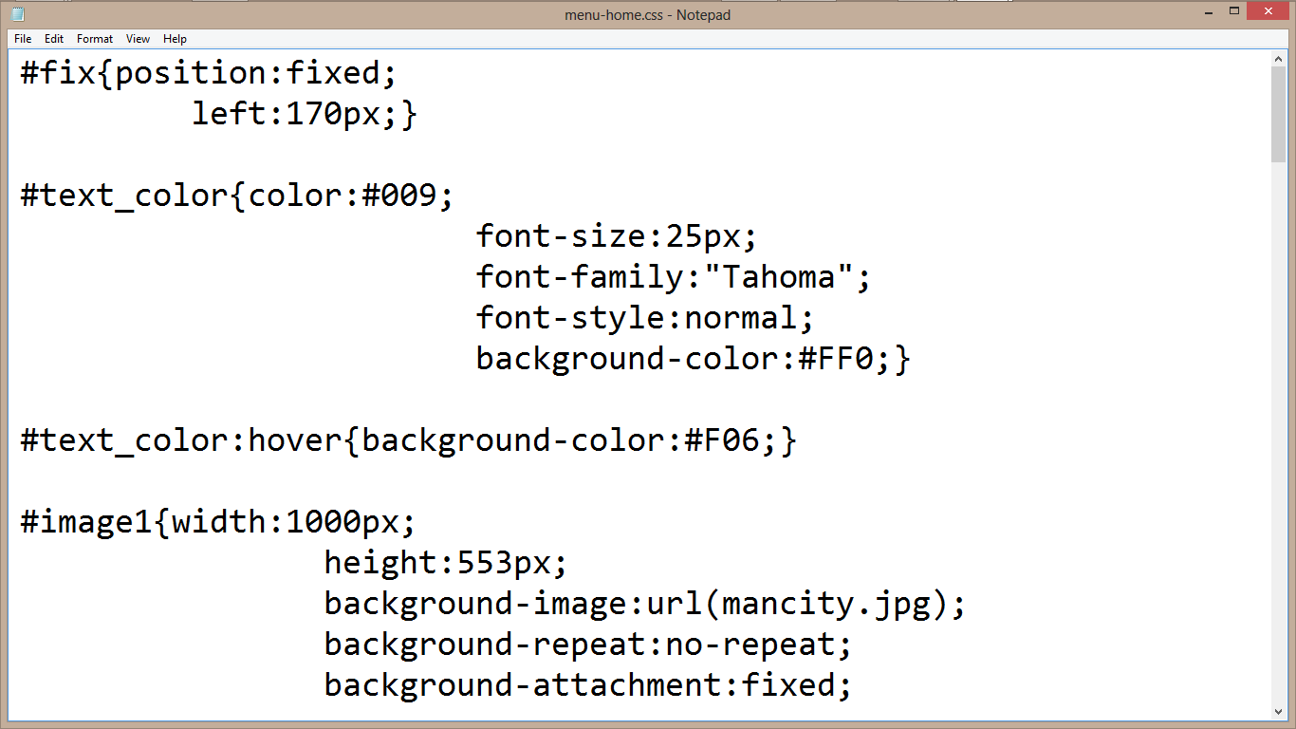

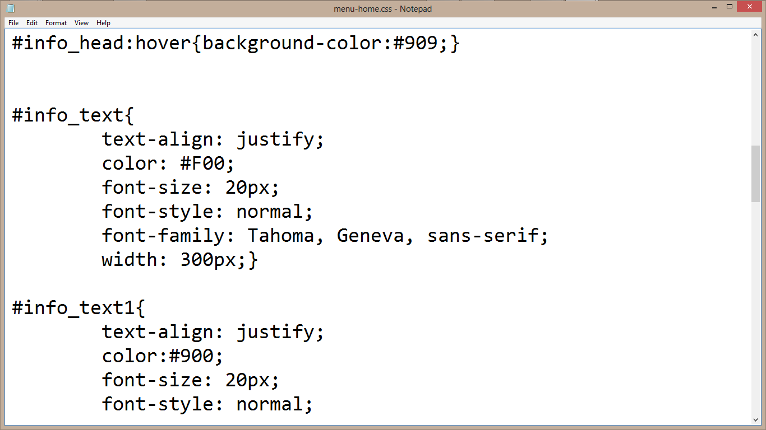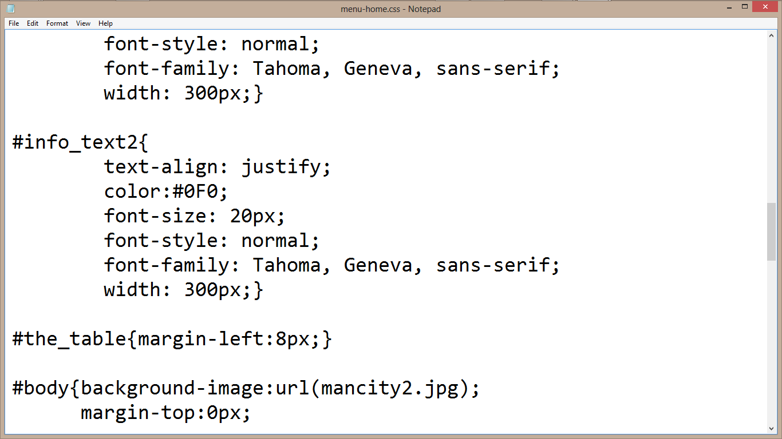

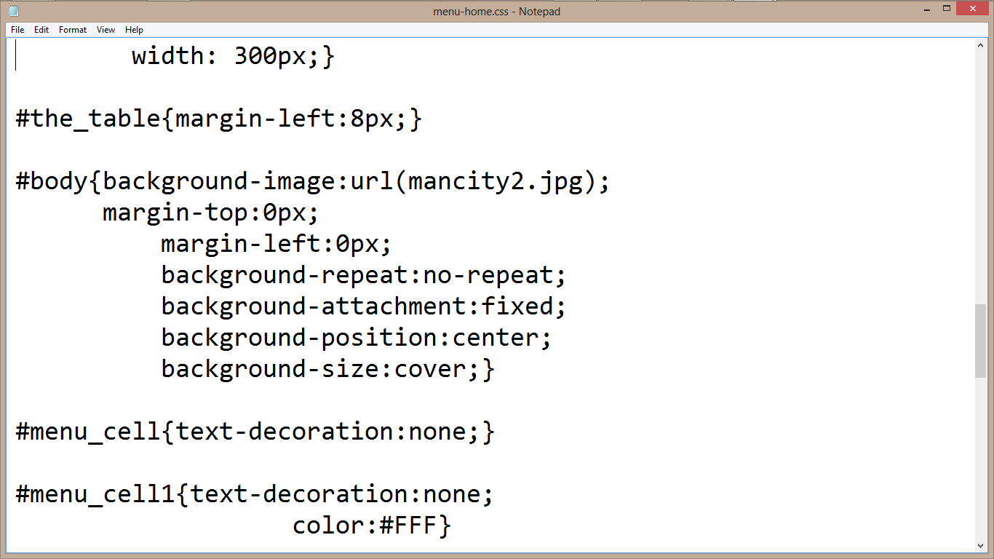

**DESIGN VIEW**

**HOME PAGE**

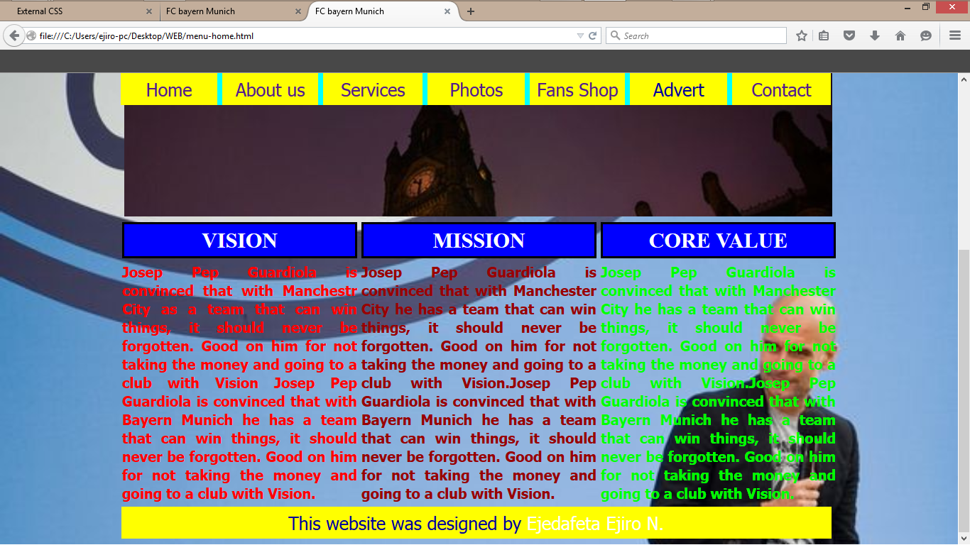

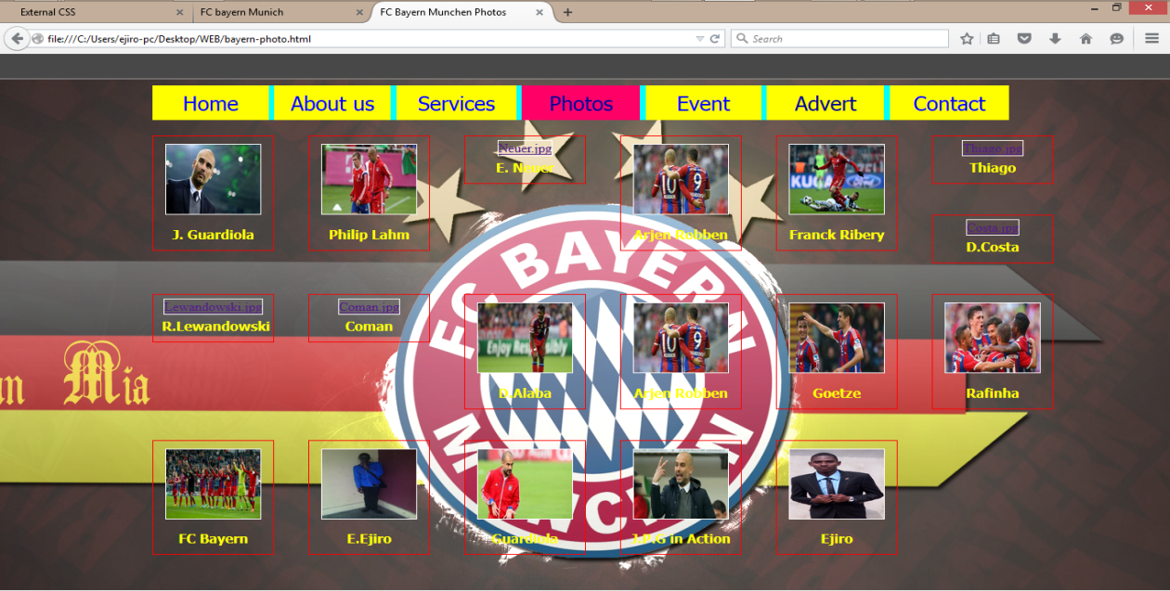**PHOTO MENU**

**2.5 JAVASCRIPT AND ITS PROPERTIES**

JavaScript is a dynamic computer programming language. It is lightweight and most commonly used as a part of web pages, whose implementations allows client side script to interact with the user and make dynamic pages. It is an interpreted programming language with object oriented capabilities. It was developed by Brenan Eich 1995-1996; it is an implementation of ECMA Script (European Computer Manufacturers Association). It was also known as livescript later change to javascript. It is use for client side web form validation. Javascript cannot run with been embedded in the HTML.

**2.5.1 FUNCTIONS OF JAVASCRIPT**

1. It is most commonly used as a client side scripting language, which implies that javascript is written into an HTML page and when a user request an HTML page with javascript in it, the script is sent to the browser.
2. It used for form validation.

**2.5.2 BROWSER DETECTION**

This refers to a feature of a web browser to execute a javascript code without any error irrespective of its version.

**2.5.3 ADVANTAGES OF JAVASCRIPT**

1. **Less server interaction:** You can validate user input before sending the page off to the server. This saves server traffic, which means fewer loads on your server.
2. **Immediate feedback to the visitors:** They don’t have to wait for a page to reload to see if they forgotten to enter something.
3. **Increased interactivity:** You can create interfaces that react when the user hovers over them with a mouse or activates them via the keyboard.
4. **Richer interfaces:** You can use javascript to include such items as drag and drop component and sliders to give a rich interface to your site visitors.

**2.5.4 JAVASCRIPT DEVELOPMENT TOOLS**

One of the major strengths of javascript is that it does not require expensive development tools. One can begin with a simple text editor such as notepad or notepad++. Since it is an interpreted language inside the context of a web browser, you don’t even need to buy a compiler.

However to make life simpler, various vendors have come up with very nice javascript editing tools, they are macromedia Dreamweaver.

**2.5.5 JAVASCRIPT SYNTAX**

JavaScript can be implemented using javascript statements that are placed within the <script>…………..</script> HTML tags in a web page. You can place the <script> tags, containing your javascript, anywhere within your web page, but it is normally recommended that we should keep it within the <head> tags

The script tag takes two important attributes:

1. **Language:** This attribute specifies what scripting language i am using.
2. **Type:** This attribute is what is now recommended to indicate the scripting language in use and its value should be set to “text/javascript”.
   * 1. **COMMENTS IN JAVASCRIPT**

JavaScript supports both c-style and c++ style comments. Thus:

1. Any text between a // and the end of a line is treated as a comment and is ignored by JavaScript.
2. Any text between the characters /* and */ is treated as a comment. This may span multiple lines.
3. JavaScript also recognizes the HTML comment opening sequence <!--. JavaScript treats this as a single-line comment, just as it does the //comment.
4. The HTML comment closing sequence --!> is not recognized by JavaScript so it should be written as //-->

**2.5.7 MY JAVASCRIPT PROGRAM TO OUTPUT MY NAME**

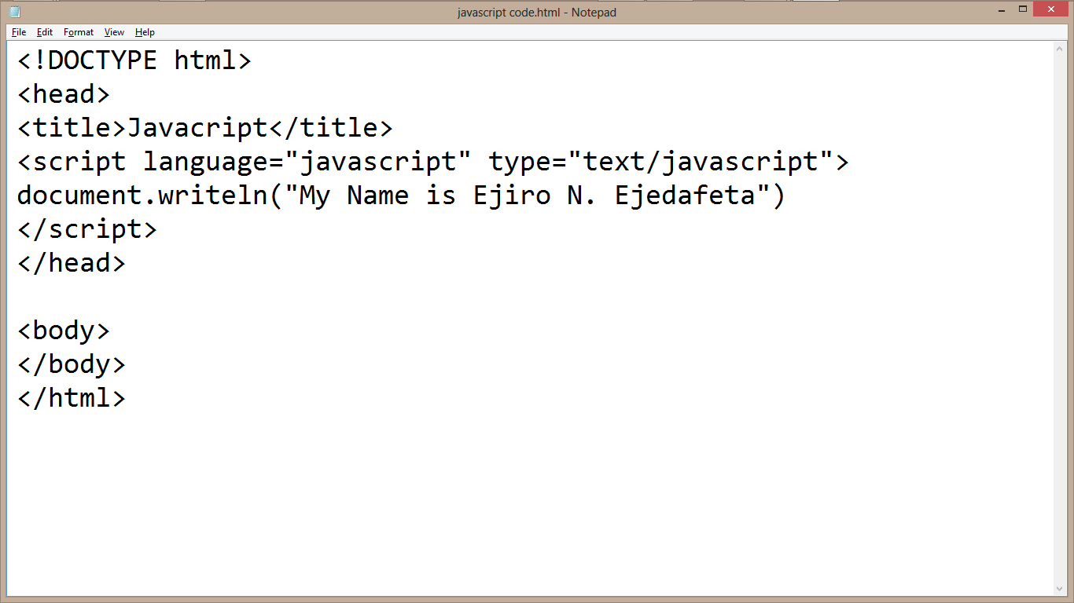**CODE VIEW DESIGN VIEW**

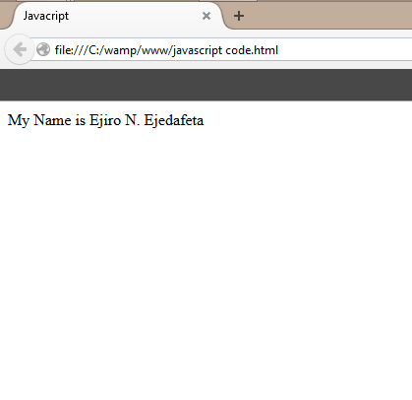

**2.5.8 HOW TO ENABLE JAVASCRIPT IN BROWSER**

I was taught that all the modern browsers come with built-in support for JavaScript. Frequently, we may need to enable or disable this support manually. The following procedure will help us to enable and disable JavaScript in our browsers.

**2.5.8.1 JAVASCRIPT IN INTERNET EXPLORER**

Here are the steps to turn on JavaScript in Internet Explorer:

* Follow **Tools-> Internet Options** from the menu.
* Select **Security** tab from the dialog box.
* Click the **Custom Level** button.
* Scroll down till you find the **Scripting** option.
* Select **Enable** radio button under **Active Scripting**.
* Finally, click Ok.

**2.5.8.2 JAVASCRIPT IN MOZILLA FIREFOX**

Here are the steps to turn on JavaScript in Firefox:

* Open a new tab -> type **about: config** in the address bar.
* Then you will find the warning dialog. Select **I’ll be careful, I promise**.
* Then you will find the list of **configure options** in the browser.
* In the search bar, type **javascript.enabled**.

There you will find the option to enable javascript by right clicking on the value of that option ->**select toggle**.

**Note:** If javascript.disabled; it gets enabled upon clicking **toggle**.

**2.5.8.3 JAVASCRIPT IN GOOGLE CHROME**

Here are the steps to turn on JavaScript in Chrome:

* Click the Chrome menu at the top right hand corner of your browser.
* Select **Settings**.
* Click **Show advanced settings** at the end of the page.
* Under the **Privacy** section, click the Content settings button.
* In the “JavaScript” section “Allow any site to run to JavaScript.

**2.5.9 DATA TYPES IN JAVASCRIPT**

One of the most fundamental characteristics of a programming language is the set of data types it support. These are the type of values that can be represented and manipulated in a programming language. They include:

* **Numbers:** This represents numeric values e.g. 100.
* **Strings:** This represents sequence of character e.g. Hello.
* **Boolean:** This represents Boolean value either true or false
* **Null:** This represents nothing i.e. it can be empty.
* **Undefined:** This represents undefined values.
* **Object:** This represent values return by functions.

**2.5.10 JAVASCRIPT VARIABLES**

This is a memory location used for holding values or used for storing values in a memory.**var** (keyword) is used to hold a value or declare a value, it makes it known to a compiler, interpreter.

E.g. var name ----- Declaration

Name = “John” ----- Initialization

**2.5.10.1 VARIABLE NAMES**

While naming the variables in JavaScript, the following rules should be kept in mind.

* You should not use any of the JavaScript reserved keywords as a variable name. For example, **break or Boolean**
* JavaScript variable names should not start with a numeral (0-9). They must begin with a letter or an underscore character. For example, **876ejiro** is an invalid name but **_876ejiro, ejiro** is a valid one.
* JavaScript variable names are case-sensitive. For example, **Ejiro** and **ejiro** are two different variables.

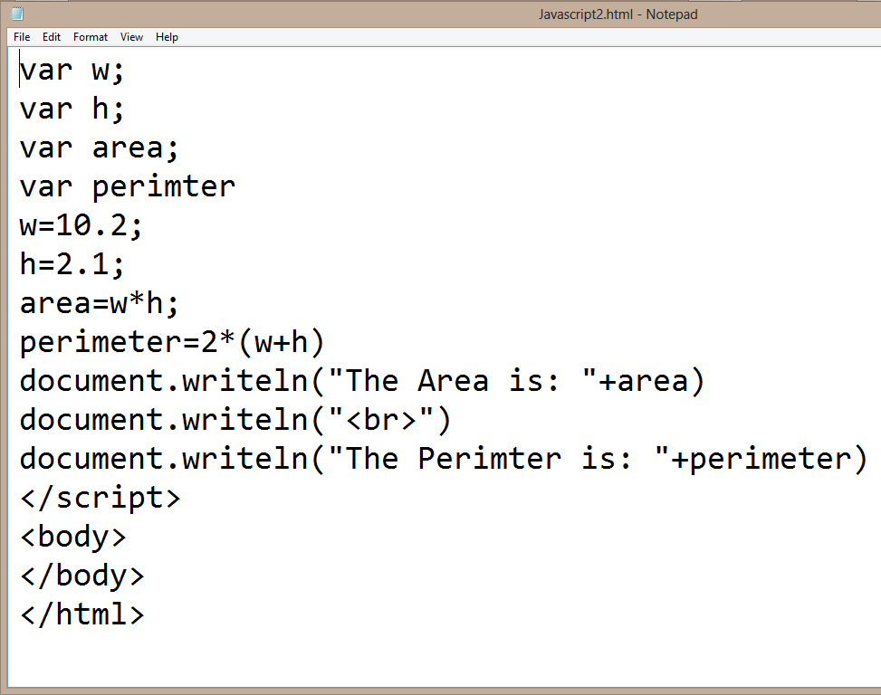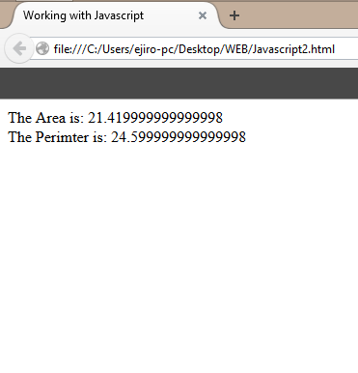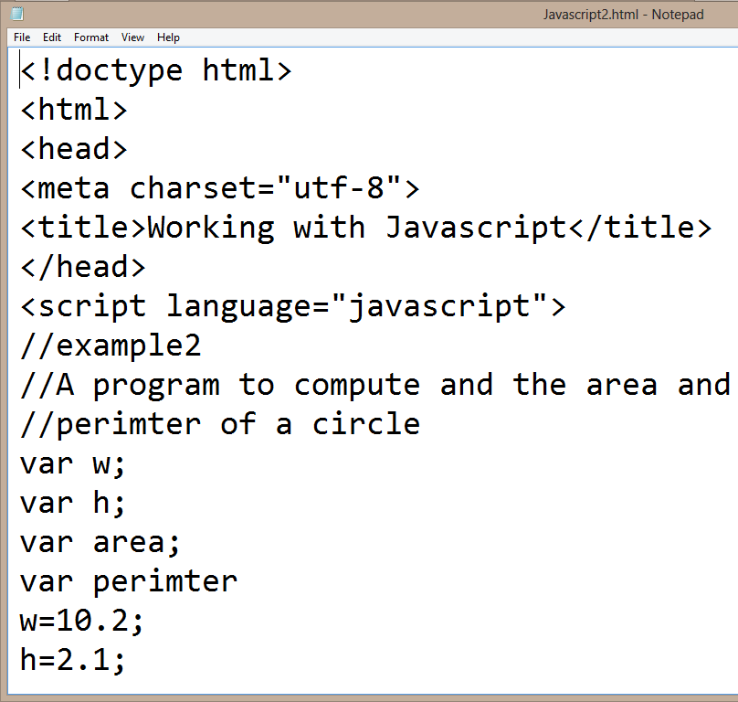**CODE VIEW DESIGN VIEW**

**2.5.11 OPERATORS**

Let me take a simple expression to give its meaning **4 + 5 = 9**. Here 4 and 5 are called operands and “+” is called the operator. JavaScript support the following types of operators they are:

1. **Arithmetic Operators:** JavaScript supports the following arithmetic operators using an expression. Assume variable A holds 10 and variable B holds 20, then
2. **Addition (+) e.g.** A + B = 30
3. **Subtraction (-) e.g.** A – B = -10
4. **Multiplication (*) e.g.** A * B = 200
5. **Division (/) e.g.** B/A = 2
6. **Modulus (%) e.g.** B%A = 0
7. **Increment (++) e.g.** A++ = 11
8. **Decrement (--) e.g.** A-- = 9
9. **Comparison Operators:** JavaScript support the following comparison operators. Assume variable A holds 10 and variable B holds 20, then;
10. **Equal (==):** Checks if the value of two operands are equal or not, if yes, then the condition becomes true. **e.g.** (A == B) is not true.
11. **Not Equal (! =):** Checks if the values of two operands are equal or not, if the values are not equal, then the condition becomes true. **e.g.** (A! = B) is true.
12. **Greater Than (>):** Checks if the value of the left operand is greater than the value of the right operand, if yes, then the condition becomes true. **e.g.** (A > B) is not true.
13. **Less Than (<):** Checks if the value of the left operand is less than the value of the right operand, if yes, then the condition becomes true. **e.g.** (A < B) is true.
14. **Greater Than or Equal To (>=):** Checks if the value of the left operand is greater than or equal to the value of the right operand, if yes, then the condition becomes true. **e.g. (A >= B)** is not true.
15. **Less Than or Equal To (<=):** Checks if the value of the left operand is less than or equal to the value of the right operand, if yes, then the condition becomes true. **e.g. (**A <= B) is true.
16. **Logical (or Relational) Operators:** JavaScript supports the following logical operators. Assume variable A holds 10 and variable holds 20, then;
17. **Logical AND (&&):** If both the operands are non-zero, then the condition becomes true. **e.g.** (A && B) is true.
18. **Logical OR (||):** If any of the two operands are non-zero, then the condition becomes true. **e.g.** (A || B) is true.
19. **Logical NOT (!):** Reverses the logical state of its operand. If a condition is true, the logical NOT operator will make it false. **e.g.!** (A && B) is false.
20. Assignment Operators
21. Conditional Operators

**2.5.12 SELECTION STATEMENTS**

When writing a program, there may be a situation when we need to adopt one out of a given set of paths. In such cases, conditional statement were used which allows our program to make correct decisions and perform right actions. The following selections statements are supported by JavaScript are:

1. **IF STATEMENT:** This is the fundamental control statement that allows JavaScript to make decisions and execute statements conditionally.

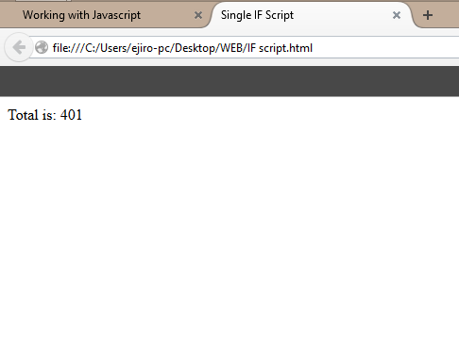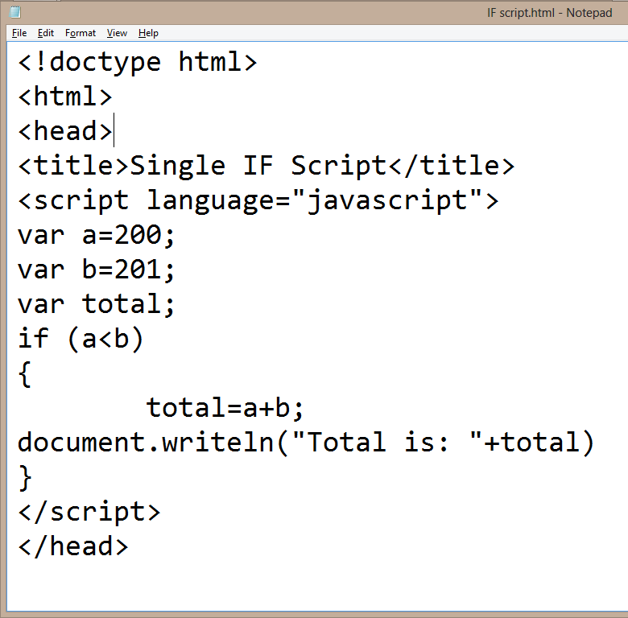**CODE VIEW DESIGN VIEW**

1. **IF-ELSE STATEMENT:** This is the next form of the selection statement that allows JavaScript to execute statements in a more controlled way.

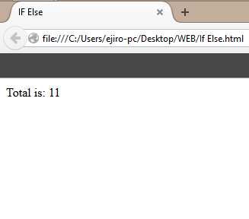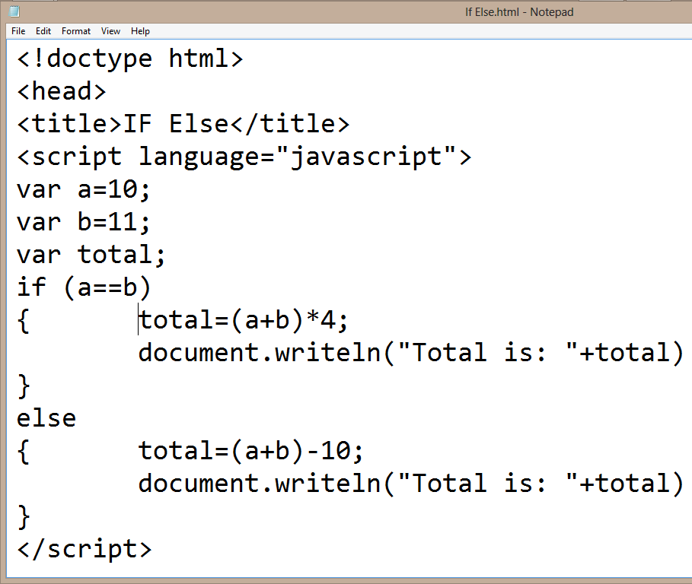**CODE VIEW DESIGN VIEW**

1. **IF-ELSE-IF STATEMENT:** This is an advanced form of if else that allows JavaScript to make a correct decision out of several conditions.

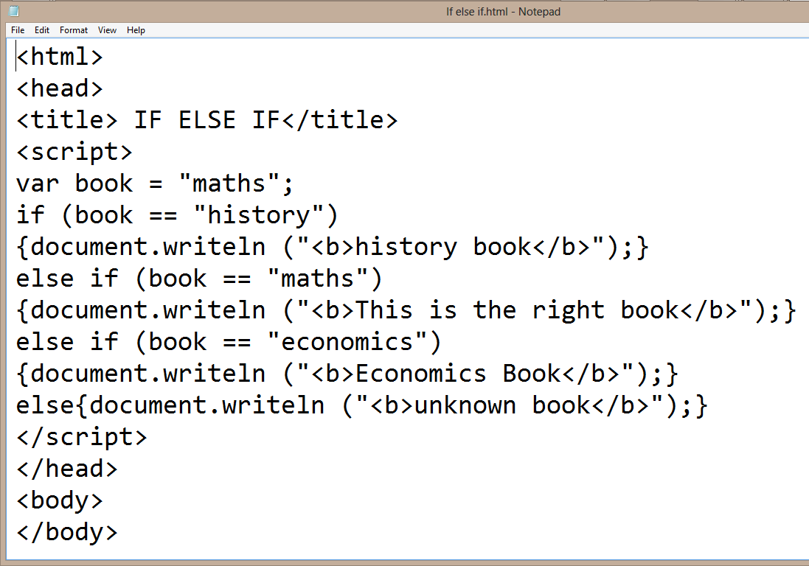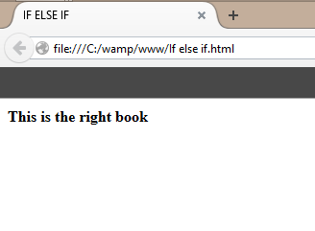**CODE VIEW DESIGN VIEW**

1. **SWITCH CASE:** Switch case is used to handle situation more efficiently than repeated **if-else-if** statements.

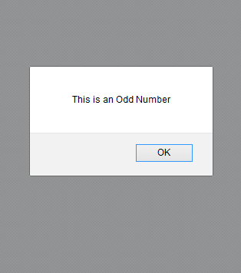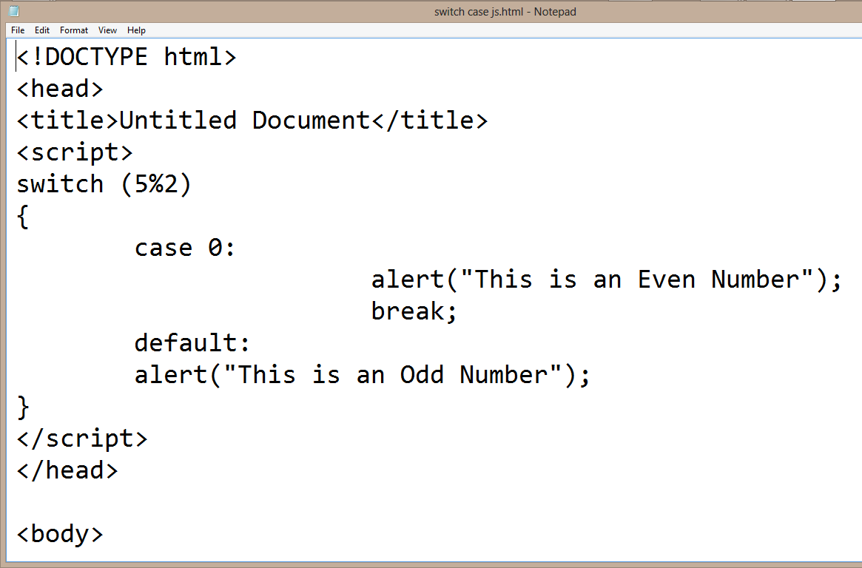**CODE VIEW DESIGN VIEW**

**2.5.13 LOOP STATEMENT**

While writing a program, you may encounter a situation where you need to perform an action over and over again. In such situations, you would need to write loop statements to reduce the number of lines. JavaScript supports all the necessary loops to ease down the pressure of programming.

1. **WHILE LOOP:** The purpose of a while loop is to execute a statement or code block repeatedly as long as an expression is true. Once the expression becomes **false,** the loop terminates.

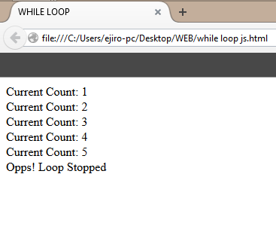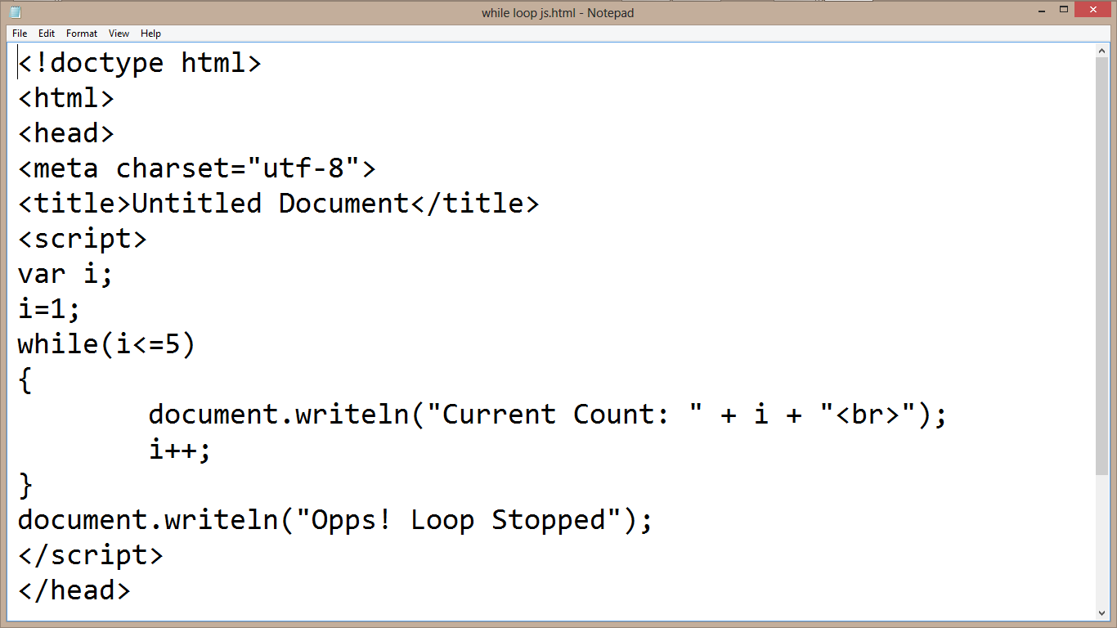**CODE VIEW DESIGN VIEW**

1. **DO WHILE LOOP:** This is similar to the **while loop** except that the condition checks what happens at the end of the loop. This means that the loop will always be executed at least once, even if the condition if false.

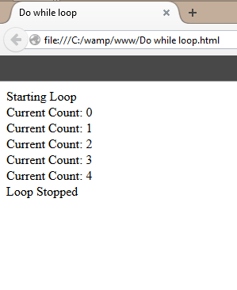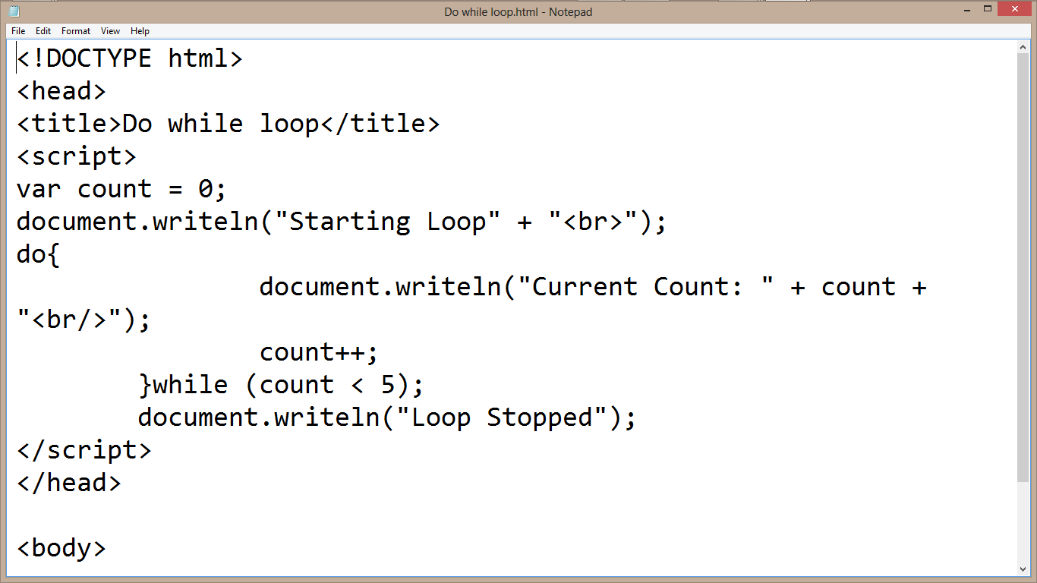**CODE VIEW DESIGN VIEW**

1. **FOR LOOP:** This is the most compact form of looping. It includes the following three (3) important parts:

* **Loop Initialization** where we initialize our counter to a starting value. The initialization statement is executed before the loop begins.
* **Test statement** which will test if a given condition is true or not. If the condition is true, then the code given inside the loop will be executed, otherwise the control will come out of the loop.
* **Iteration statement** where you can increase or decrease your counter.

**Note:** All this three (3) parts are inserted in a single line separated by semicolons.

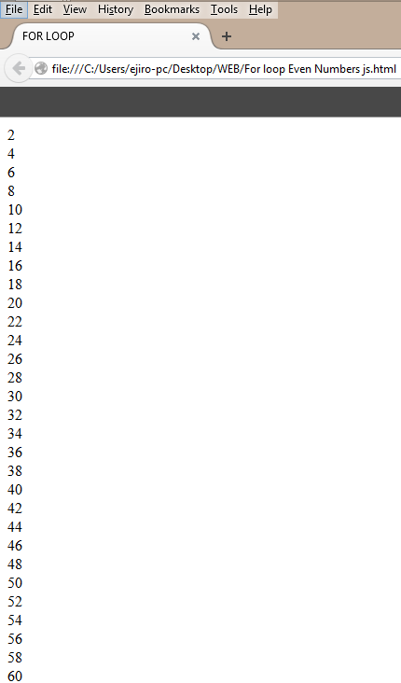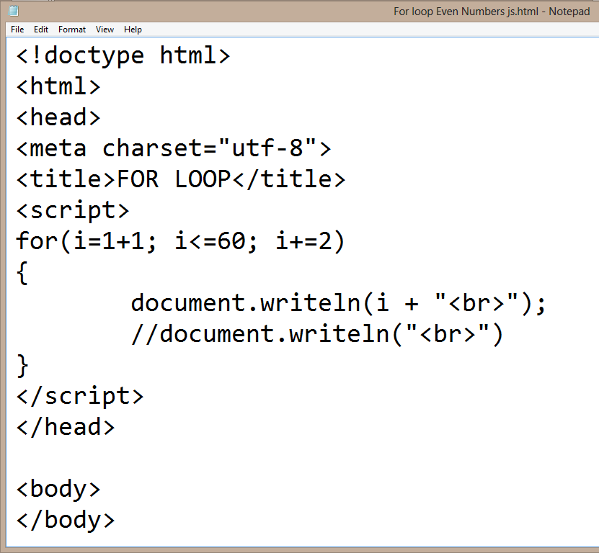**CODE VIEW DESIGN VIEW**

**2.5.14 FUNCTIONS**

A function is a group of reusable code which can be called anywhere in your program. This eliminates the need of writing the same code again and again. It helps programmers in writing modular codes. It allows a programmer to divide a big program into a number of small and manageable functions.

Before we use a function, we need to define it. The most common way to define a function in JavaScript is by using the function keyword, followed by a unique function name, a list of parameters (this might be empty), and a statement block surrounded by curly braces.

Also to invoke a function somewhere later in the script, you would simply need to write the name of that function.

**CHAPTER THREE**

**SKILLS ACQUIRED AND CHALLENGES ENCOUNTERD**

**3.0 TECHNICAL SKILLS ACQUIRED**

Below are list of skills i acquired during my **Industrial Training** at **START INNOVATION HUB**

* Deep knowledge in understanding front-end web development.
* Ability to create websites with the help of HTML.
* Ability to create websites with the help of HTML and CSS.
* Ability to create a standardize websites with the help of HTML, CSS, JAVASCRIPT.
* Debugging errors and been creative in arrangement of codes.
* Installing git and pushing projects to github.
* How to use both CSS and javascript framework to make a website responsive and easy to interact with by users.
* Installing several developmental tools like VS codes, Dreamweaver, and Atom, knowing how to use them effectively.
* Learning how to work with designed Templates and creating Templates.
* Learning how to work on live projects.

**3.1 SOCIAL AND FUNCTIONAL SKILLS ACQUIRED**

* Enhanced communication skills.
* Ability to identify and solve problems relating to web development.
* Decision making, critical thinking, organizing and planning.
* Ability to work with team.
* Enhanced teaching and effective learning skills
* Good customers services orientation skill

**3.2 PERSONAL INPUT TOTHE COMPANY (START INNOVATION HUB)**

* Teaching and assisting students (Clients) through their lessons.
* Assist students with their codes when not running.
* Running of errands to boost activities in the workplace.
* Check and work on colleague’s systems when challenge with an error code.
* Help in installing various development applications to colleagues and client.

**3.3 CHALLENGES ENCOUNTERD**

* Difficulty in seeking for IT attachment.
* Lack of transportation fee.
* I was not paid by SIWES.

**CHAPTER 4**

**CONCLUSION AND RECOMMENDATIONS**

**4.0 CONCLUSION**

My six (6) months Industrial Training at AD’MAS I.T PLACE was a huge success and a great time of acquisition of knowledge and skills. Through my training i was able to appreciate my chosen course of study even more, because i had the opportunity to blend the theoretical knowledge acquired from school with the practical hands-on application of knowledge gained here to perform very important tasks that contributed in a way to my productivity in the company. My training here has given me a broader view to the importance and relevance of Computer Science (Web Design Development) in the immediate society and the world as a whole, as i now look forward to impacting it positively after graduation. I have also been able to improve my communication and presentation skills and thereby developed good relationship with my fellow colleagues at work. I have also been able to appreciate the connection between my course of study and other disciplines in producing a successful result.

**4.1 RECOMMENDATIONS:**

* School should provide a place of attachment for student.
* Allowances should be paid to students during their programme just like NYSC and not after. This would help them a great deal to handle some financial problems during their training course.
* Supervisor should always visit student monthly in their various places of attachment.

**REFERENCE**

**PAPER**

* Student industrial work experienced scheme 2015/2016 handbook
* Web design manual by industrial supervisor Mr. Patrick Inyangetoh
* Web design and Advance Manual by Industrial based supervisor Mr. Patrick Inyangetoh

**LINK**

* [**http://www.w3schools.com**](http://www.w3schools.com)
* [**http://www.codepen.com**](http://www.codepen.com)
* **http://www.freecodecamp.com**
* **http://www.tutorialpoint.com**
* [**http://www.tizag.com/CSS**](http://www.tizag.com/CSS)
* **http://www.CSS/HTML/116583/article.com**